User and Group Management in Linux
Linux provides powerful tools for managing users and groups. This document explains how to create groups, add users, manage group memberships, delete groups, and check user password status.

Creating Groups
To create a new group, use the command:
Groupadd [groupname]
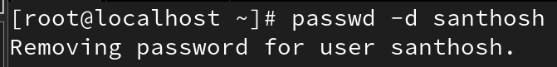


This creates a new group with the specified name. A unique Group ID (GID) will be assigned automatically. To verify that the group was created, check the /etc/group file.
Example:
cat /etc/group /grep [groupname]

Adding a User to a Group
To add a user to a secondary group, you can use either of these commands:
gpasswd -a[username] [groupname]

usermod -aG [groupname]
[username]
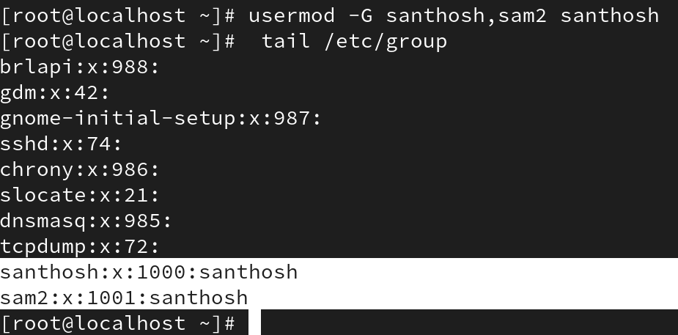
Explanation:
- The 'gpasswd -a' command adds the user to the specified group.
- The 'usermod -aG' command adds the user to one or more secondary groups.
- The '-G' option specifies secondary groups, while the '-g' option is used for the primary group.

Removing a User from a Group
To remove a user from a group, use the command:
gpasswd -d [username] [groupname]
This removes the user from the specified group. The user will still remain in their primary group.

Deleting a Group
To delete a group, use the command:
groupdel [groupname]

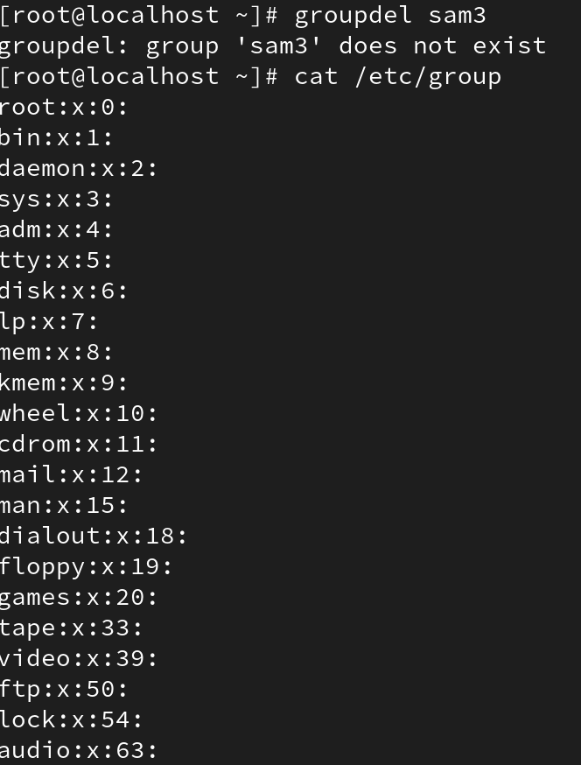
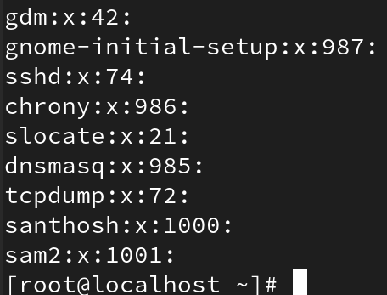
This deletes the group. However, if the group is the primary group of a user, it cannot be deleted. You must first change the user’s primary group before deletion.

Checking Password Status
To check the password status for a user, use the command:
passwd -S [username]
This displays information about the user’s password status. The output includes a code indicating the password state:
- * PS: Password is set.
* PL: Password is locked.
* NP: No password is set.

